A survey by g0v.tw Jothon · 5-minute summary

Who Builds Civic Tech in Taiwan, and What Holds Them Back?
What 127 people around g0v.tw told us about getting in, getting stuck, and staying
By Claire Cheng | 127 valid responses collected up to 20 July 2026
Picture a g0v.tw hackathon. About 100 people from different cities, backgrounds and ages fill a room. Anyone can take three minutes to pitch an idea, then find people to build it with. g0v.tw holds one every two months.
g0v.tw is a grassroots civic tech community founded in Taiwan. In 2026, g0v.tw Jothon, the team that organizes these hackathons, ran a survey to learn who takes part and what gets in their way. This page sums up what 127 people told us.

The hard part isn't finding people, it's keeping going
At every hackathon, many projects are looking for partners. But for people who have actually worked on a project, finding partners is not the hardest part. The hardest part is keeping progress steady, making the results count, and core members burning out.

Three groups, three stages
We sorted the 127 people by how close they are to civic tech:
Group | People | Who they are
The Curious | 26 | Have heard of or seen civic tech, but not taken part
The Users | 54 | Know the community, and most have used a civic tech tool or joined a discussion, but have not worked on a project
The Builders | 47 | Have worked on at least one civic tech project

Questions about real project experience, such as what gets stuck and what keeps people going, were answered only by the 47 Builders.

What we found

1. Projects stall because of momentum, not a lack of people
Among the 47 Builders, the most common problems were:
- Progress is hard to keep steady: 38%
- Results struggle to make a real difference: 36%
- Core members burn out, with one person holding the project up: 32%
Not finding partners ranked only fourth (23%). And the more say someone has in a project, the more likely they are to burn out: 6 of the 10 who started their own project said core-member burnout clearly held them back, compared with 1 of 8 who joined a project someone else led.
How much each difficulty troubles people (all ratings from 1 to 5)
Sorted by how many rated it 3 or higher (there was no “not experienced” option, so a rating of 1 covers both “never happened” and “happened but had no impact”)
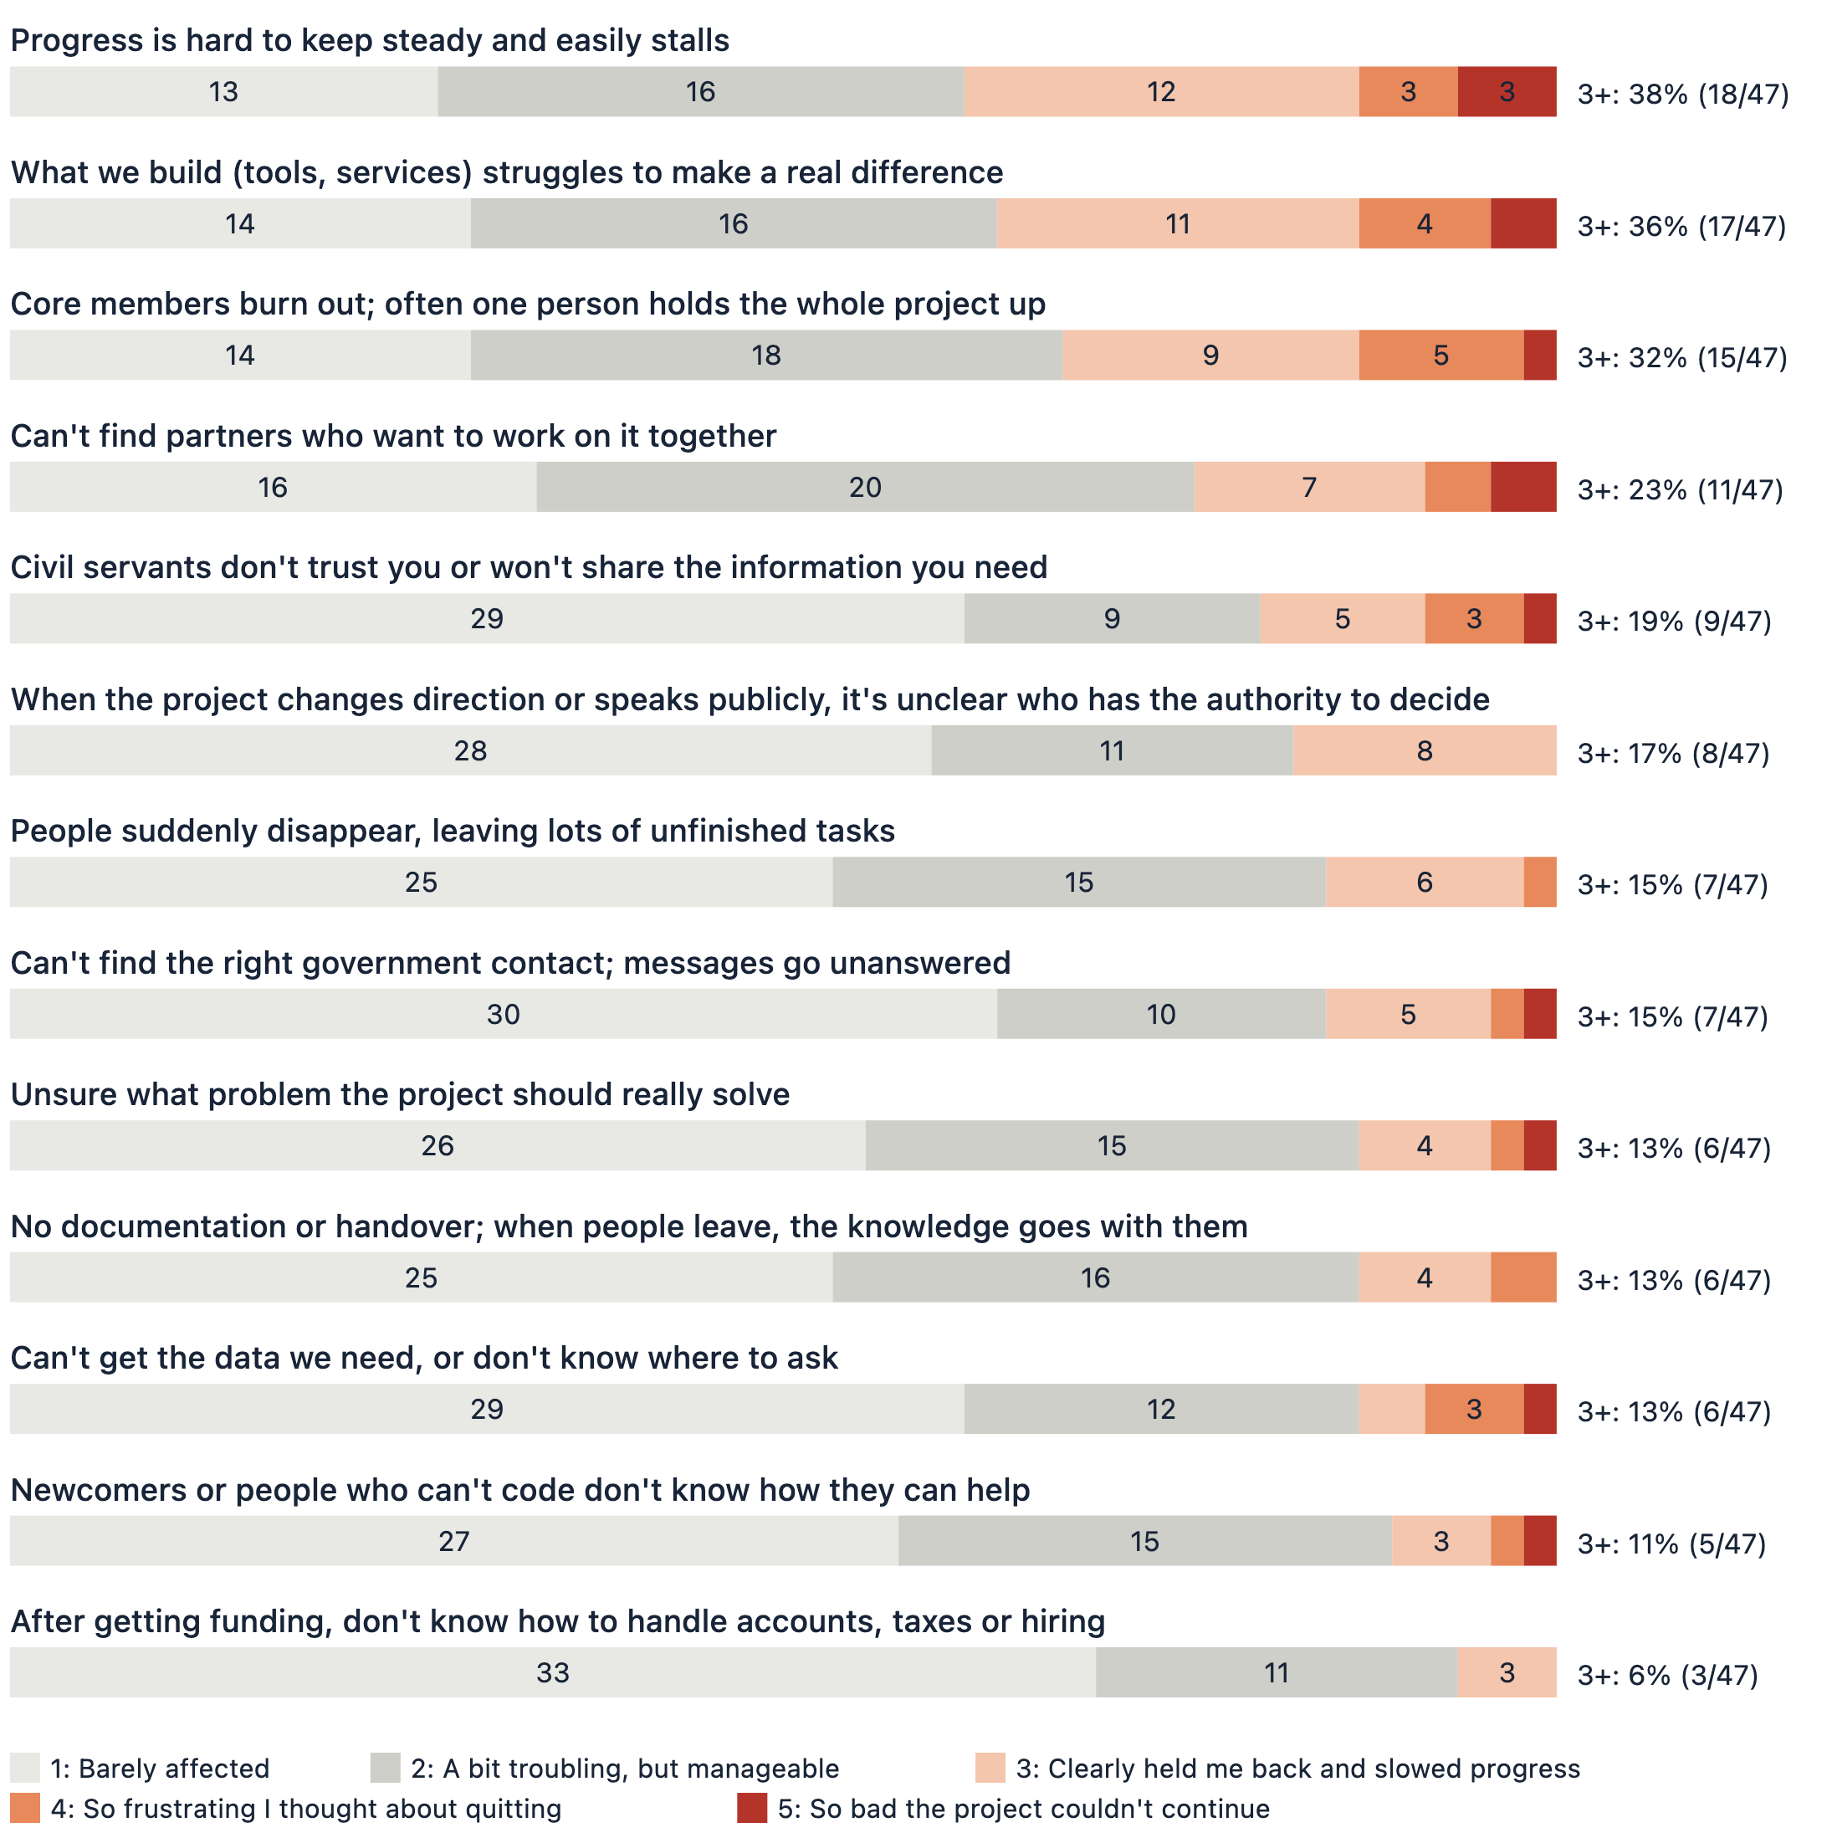
Base: 47 Builders (all 47 rated every item)

2. A shared goal brings people in, and keeps them there
39 of the 47 Builders joined because they believed in what the project wanted to achieve, and 39 still name it as a reason to stay. Comparing what first drew them in with what keeps them now, some motives grew: building skills and a portfolio went from 6 people to 9. The sense of belonging to the community faded the most, from 20 people to 17.

3. Newcomers get stuck at "where do I start?", not "I can't code"
A common assumption is that civic tech is for coders. But when we asked the 26 Curious what kept them from joining, the top answers were about finding a way in:
- Don't know which projects or issues exist: 62%
- No one to show them the way, and worry they won't fit in or be useful: 54%
- Don't know how to join: 50%
- Feel they would need to code: 35%, fourth place
Among the Builders, only 28% wrote code. Topic research and project management were the most common skills, at 51% each. And while 65% of all respondents get g0v.tw event news through at least one official channel, getting the news does not mean knowing what to do, or having someone to ask.
What holds back people who have not taken part
Up to 3 choices. Base: the 26 Curious (the 54 Users were not asked this question)
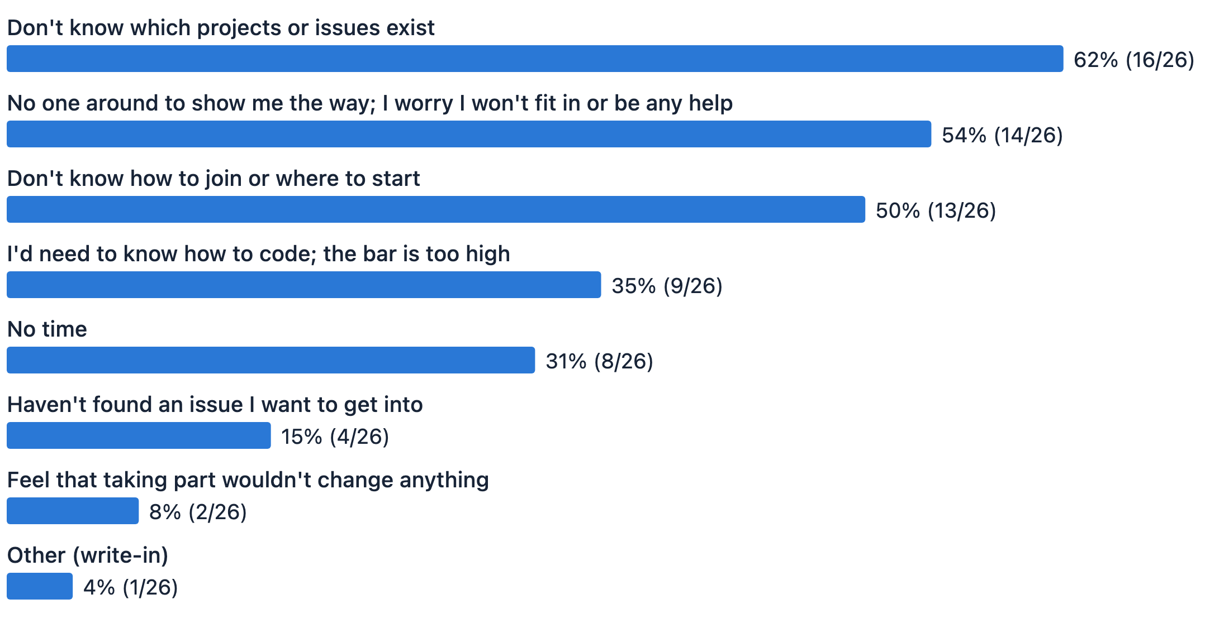
Base: the 26 Curious
Skills the Builders have contributed
Base: 47 Builders (more than one answer allowed, so totals exceed 100%; many people do several things)
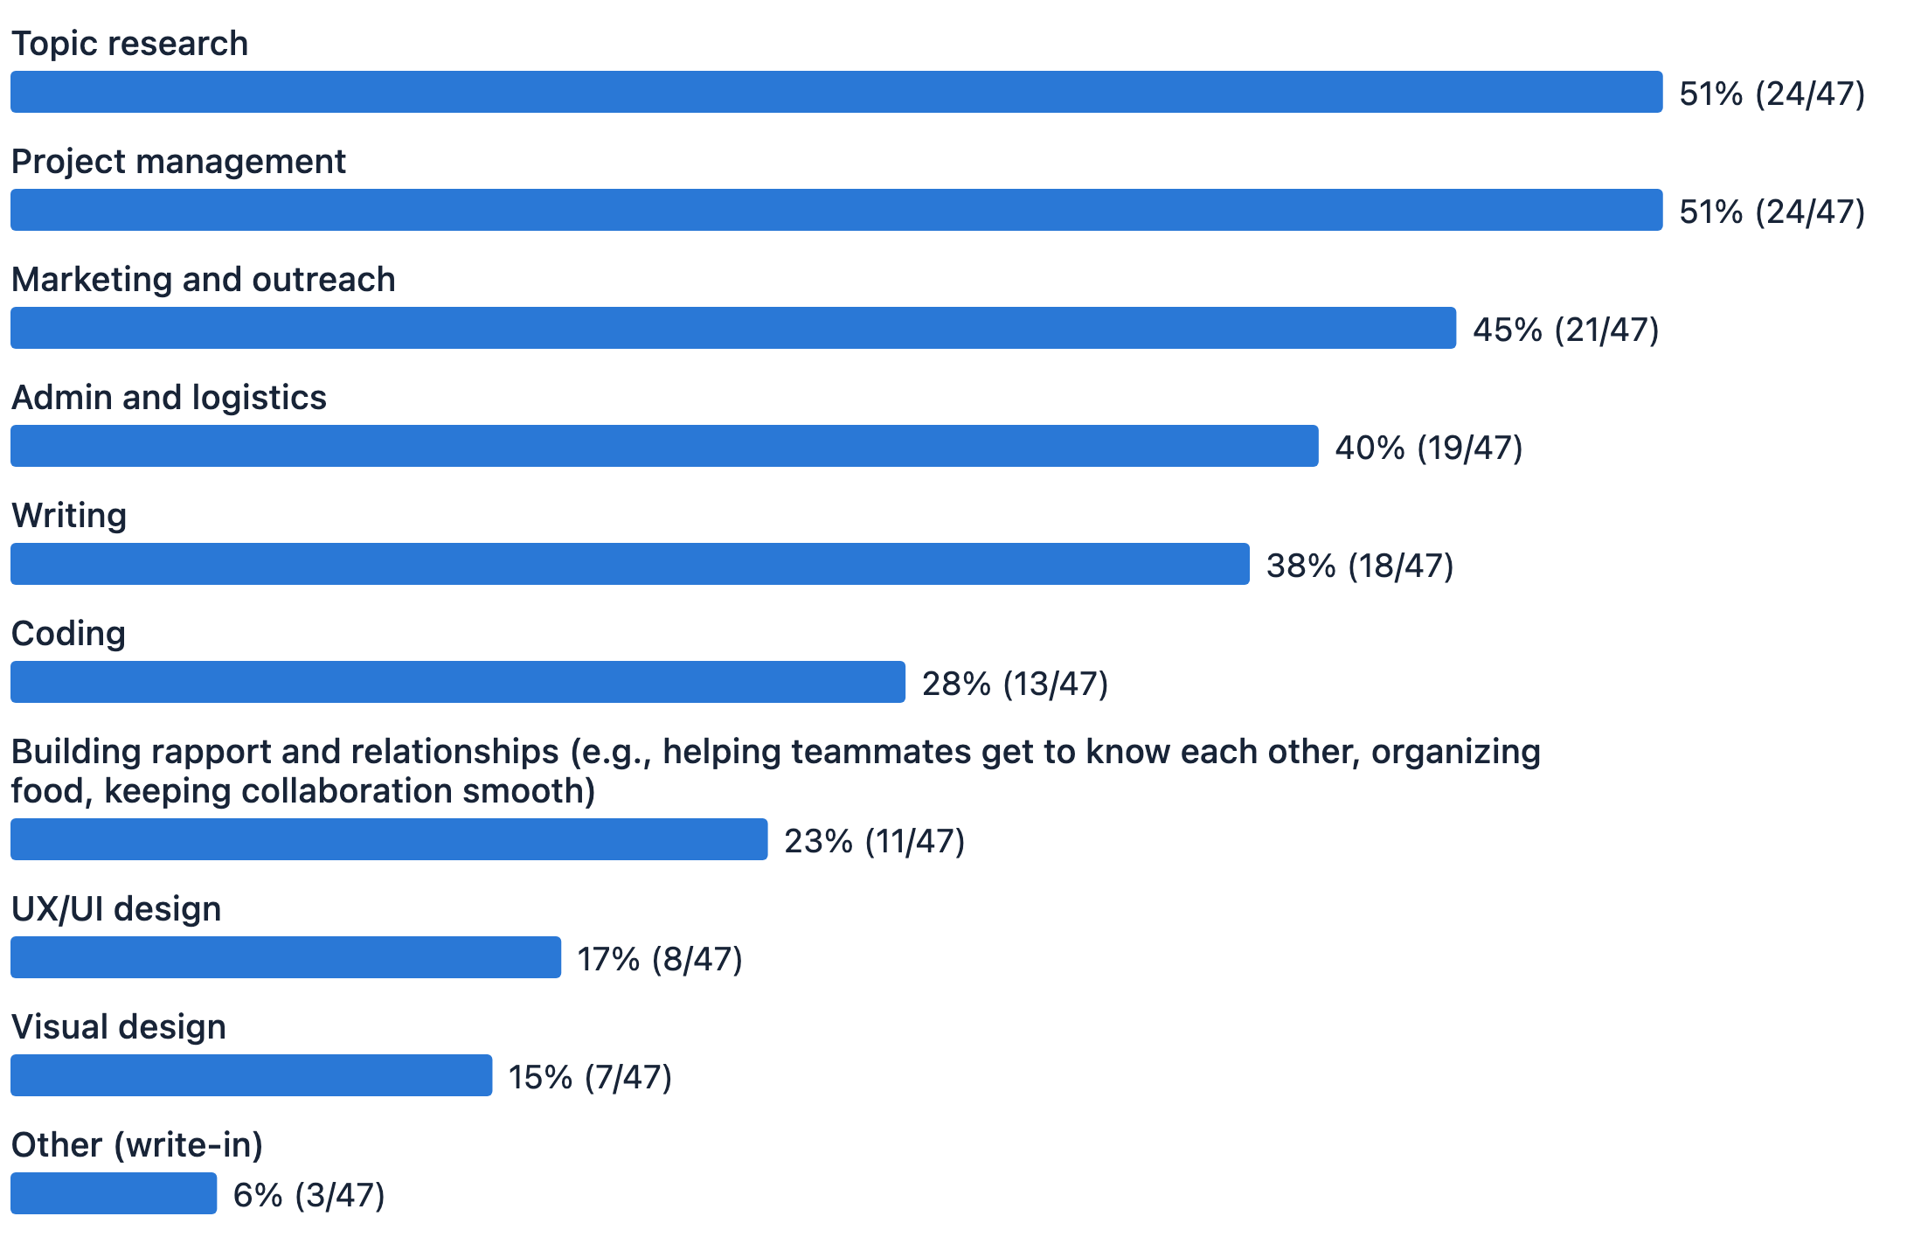
Base: 47 Builders

4. Funders want a clearly explained problem, and early ideas struggle most
27 respondents had given financial support to civic tech projects, and 26 of them were already part of the community. What they valued most was a problem that matters and is clearly explained (16 of 27), and a project that matches issues they care about (14 of 27). More than half (14 of 27) said projects that are still just an idea have the hardest time finding support. Only 3 picked projects that already have a prototype.

What other communities can borrow
- Make projects easy to find. Newcomers' first question is "what is there to join?" Taiwan already has Civic Tech Taiwan, a database of civic tech projects; the challenge is making sure it reaches people at the moment they want to start.
- Give newcomers someone to ask. Having no one to show the way was the second biggest barrier.
- Invite more than coders. More Builders contribute topic research, project management, outreach and writing than code.
- Look after the people holding projects up. Those with the most say are the most likely to burn out.
- Support is not only money. Among the Builders, more had used personal networks (66%) than funding (47%). Introducing an expert, connecting a team with a government contact, or offering a meeting space all count.

Your next step
Most of these pages are in Mandarin.

🌱 Still looking for a way in
- Browse projects on Civic Tech Taiwan: start with an issue you care about
- Check upcoming hackathons: ask people in person and join in on the day
- Join g0v's Slack: find the channels where people are actively working

🔧 Already working on a project
- Read the g0v civic tech project and community handbook: project experience collected by the community
- Pitch at a hackathon to find teammates: three minutes on stage to say who you need
- Use this survey's raw data in your proposal: open data, CC BY 4.0

💡 Looking to collaborate
- See what help projects are asking for: each project idea lists the skills it needs
- Meet teams at a hackathon: introducing experts, connecting a team with government contacts or offering a meeting space all help

About this survey
The survey was sent out by g0v.tw Jothon in 2026 and analysed by Claire Cheng. It covers 127 valid responses collected up to 20 July 2026. The survey was in Chinese; answer options shown here are translated.

Explore more
- Full report (English): all findings, charts and data notes
- Full report (Chinese): the original report
- Raw survey data: anonymized responses, CC BY 4.0 (Google Sheets, in Chinese)
- Analysis code and data tables: on GitHub, so anyone can check every number
- Civic Tech Taiwan: a database of projects and how-to guides, run by g0v.tw Jothon (in Chinese)
- g0v.tw: the community’s official website
Read the full report →
CC BY 4.0, by g0v.tw jothon & Claire Cheng

